**Bigg Boss Voting Zone**

### A MINI PROJECT REPORT

#### Submitted by

#### Group/Team No: G24A/T5

**Japneet Kaur 2210990433**

**Japneet Singh 2210990434**

**Japish Bagga 2210990432**

**Japtoz Singh Puri 2210990435**

#### in partial fulfillment for the award of the degree of

## BACHELEOR OF ENGINEERING

***in***

COMPUTER SCIENCE & ENGINEERING



**CHITKARA UNIVERSITY**

**CHANDIGARH-PATIALA NATIONAL HIGHWAY**

**RAJPURA (PATIALA) PUNJAB-140401 (INDIA)**

##### MAY, 2023

**ABSTRACT**

The VOTE-OFF online voting system is a digital platform that enables viewers of the popular reality TV show to vote for their favorite contestants using the internet. The system is designed to allow fans to participate in the show by selecting their preferred housemates and influencing the outcome of the competition.

The voting system is integrated into the VOTE-OFF website or mobile application, where users can create an account and log in to access the voting portal. The system typically displays the photos and names of the contestants, along with their respective voting numbers or codes. Users can cast their votes by clicking on the photo or name of their preferred contestant, which is then recorded in the system's database.

The VOTE-OFF online voting system provides an easy and convenient way for fans to participate in the show and support their favorite contestants. The system is also transparent and efficient, as it allows viewers to monitor the voting results in real-time and ensures that only valid votes are counted. However, concerns about vote manipulation and cheating have been raised, and measures to prevent such activities must be implemented to ensure the integrity of the voting process.

Overall, the VOTE-OFF online voting system is a valuable tool for engaging viewers and creating a sense of community around the show. By allowing fans to have a say in the outcome of the competition, the system enhances the entertainment value and excitement of the show, while also promoting interactivity and audience engagement.

###### **TABLE OF CONTENTS**

|  |  |  |
| --- | --- | --- |
| Sr no | Section | Page no |
| 1 | **Introduction** | **1** |
| 2 | **Problem Statement** | **2** |
| 3 | **Technical Details** | **3** |
| 4 | **Key Features** | **4** |
| 5 | **Project Advantages** | **5** |
| 6 | **Bonus Feature** | **6** |
| 7 | **Results** | **7** |
| 8 | **Conclusion with Future Scope** | **10** |
| 9 | **References** | **11** |

**INTRODUCTION**

The VOTE-OFF online voting system is a powerful tool that has revolutionized the way viewers of the popular reality TV show can participate and engage with the competition. By leveraging the power of the internet, the system allows fans to cast their votes for their favorite contestants from anywhere in the world1, at any time, using a computer or mobile device.

This digital platform has transformed the way we interact with reality TV shows, offering viewers a more convenient and accessible way to participate in the competition. By enabling fans to vote online, the VOTE-OFF online voting system has created a more inclusive and engaging experience for viewers, while also helping to build a sense of community and excitement around the show.

The VOTE-OFF online voting system has also helped to increase transparency and efficiency in the voting process, ensuring that only valid votes are counted and providing real-time updates on the voting results. However, it is important to address concerns about vote manipulation and cheating to maintain the integrity of the voting process.

Overall, the VOTE-OFF online voting system has transformed the way we engage with reality TV shows, offering a more convenient and interactive experience for viewers and enhancing the entertainment value of the competition.

**PROBLEM STATEMENT**

* A Voting platform is designed to show the increase/ decrease in the votes of particular contestant using HTML, CSS and JavaScript.
* The platform should look quite dynamic to show the progress bars of each contestant.

**TECHNICAL DETAILS**

* HTML and CSS: HTML is used to structure the content and layout of the web page, while CSS is used to define the visual style and design.
* Responsive design: The project is designed and developed to be responsive, meaning that it is adaptable to different screen sizes and device types, such as desktops, tablets, and smartphones.
* Cross-browser compatibility: The project is tested and optimized for different web browsers to ensure that it works consistently and effectively across various platforms and devices.
* Accessibility: The project is designed and developed to be accessible to users with disabilities, such as providing alternative text for images.

**KEY FEATURES**

* Voting system: A secure and user-friendly voting system that allows viewers to vote for their favorite contestants.
* Real-time results: The website should display real-time results to keep viewers engaged and informed about the voting process.

**PROJECT ADVANTAGES**

The VOTE-OFF online voting system has several advantages that make it a powerful tool for engaging viewers and promoting audience participation in the reality TV show. Some of these advantages include:

* Increased audience engagement: The online voting system allows viewers to actively participate in the show by voting for their favorite contestants, creating a sense of engagement and investment in the competition.
* Real-time feedback: The online voting system provides real-time feedback on the voting results, giving viewers a sense of immediacy and involvement in the show.
* Accessibility and inclusivity: The online voting system allows viewers from different geographic locations and time zones to participate in the voting process, promoting inclusivity and accessibility.
* Increased transparency: The online voting system provides transparency in the voting process, ensuring that the results are fair and accurate.
* Data collection: The online voting system can collect valuable data on viewer preferences and behaviors, providing insights that can be used to improve the show and tailor it to the audience.

Overall, the VOTE-OFF online voting system offers several advantages that enhance the viewer experience and promote engagement and inclusivity while providing valuable data and insights to improve the show.

**BONUS FEATURES**

* Predictive analysis: Use predictive analysis to suggest the likely winner of the show based on historical voting patterns and user behavior.

**RESULTS**

* Welcome Page:





* Channel Page:





* Contestant and Result Page:



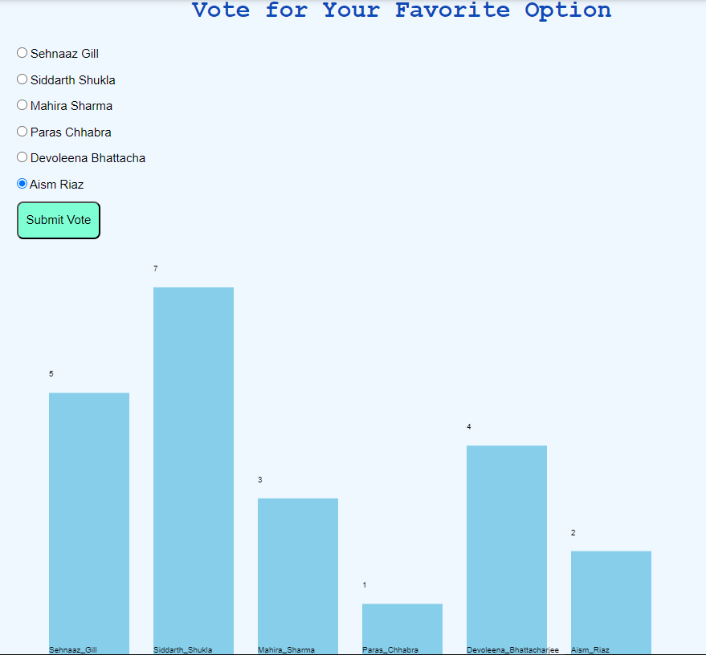

**CONCLUSION with Future Scope**

In conclusion, the online VOTE-OFF voting system project is an innovative and engaging way to promote audience participation and engagement in the reality TV show. The advantages of the system, including increased audience engagement, real-time feedback, accessibility, and cost-effectiveness, make it an attractive option for broadcasters and viewers alike. Additionally, the system provides valuable data and insights into viewer preferences and behaviors, which can be used to improve the show and tailor it to the audience.

Looking to the future, there is significant potential for the online VOTE-OFF voting system project to continue to evolve and improve. For example, the system could incorporate new technologies such as artificial intelligence and machine learning to better understand and predict viewer preferences and behaviors, leading to more personalized and engaging experiences. Additionally, the system could leverage social media and other digital platforms to further promote audience engagement and expand the reach of the show.

Overall, the online VOTE-OFF voting system project has significant potential to enhance the viewer experience, promote engagement and inclusivity, and provide valuable data and insights for the improvement of the show. As technology continues to evolve, there is significant room for innovation and growth in this area, making the future of the online VOTE-OFF voting system project an exciting prospect.

**REFERENCES**

* ***WEBSITES:***
  + <https://codepen.io/>
  + <https://www.w3schools.com/>
  + <https://www.codeschool.co/>
  + <https://www.geeksforgeeks.org/>
* ***BOOKS:***
  + ‘Web Enabled Commercial Application Development using HTML, JavaScript, DHTML and PHP’ by Ivan Bayross, 4th Edition, BPB Publications.
  + ‘The Complete Reference HTML & XHTML’ by Thomas Powell, 5th Edition, Tata McGraw-Hill Company Limited.